What does what??

* Entity: everything in the game is an Entity. Internally is just a unique ID used to keep together a group of components.
* Components: They hold all the data and have no methods about logic.
* Systems: They got a method (update) that gets called every single game loop. They operate on some particular components, for example, the movement system will first get all the entities that have the movement component and will move them. Remember lock metaphor, a system only works if the entities have the components it requires or more.

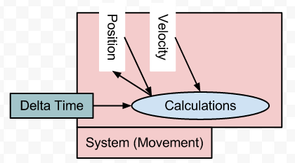

* Entity factory: Has one method for creating every entity.
* Entity manager: Is the database of the system. Holds info about which entities got which components, allows creating new entities and adding and removing components from the entities, etc.
* Engine: The glue that holds everything together. Contains an entity manager, a factory and a list of systems. When using the framework, we just call the update method of the engine and it updates every system following a priority order.

Useful components and systems:

* Components:
* Position
* Movement or Velocity
* Camera
* Render
* Animation
* Game State
* Systems:
* Game Manager (main logic system)
* Animation System
* Render System
* Movement System

Nice priority used in Asteroids game:

engine.addSystem( new GameManager( creator, config ), SystemPriorities.preUpdate );

engine.addSystem( new MotionControlSystem( keyPoll ), SystemPriorities.update );

engine.addSystem( new GunControlSystem( keyPoll, creator ), SystemPriorities.update );

engine.addSystem( new BulletAgeSystem( creator ), SystemPriorities.update );

engine.addSystem( new DeathThroesSystem( creator ), SystemPriorities.update );

engine.addSystem( new MovementSystem( config ), SystemPriorities.move );

engine.addSystem( new CollisionSystem( creator ), SystemPriorities.resolveCollisions );

engine.addSystem( new AnimationSystem(), SystemPriorities.animate );

engine.addSystem( new RenderSystem( container ), SystemPriorities.render );